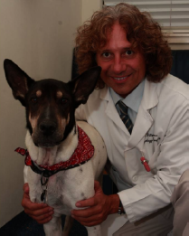
Filippo Adamo, DVM, Dipl. ECVN, Veterinary Neurology Specialist
President Bay Area VNC (Veterinary Neurology Neurosurgery Consulting)
Chief of Neurology/Neurosurgery at East Bay Veterinary
Specialists, Walnut Creek: (925) 937-5001 and at Sequoia Veterinary Hospital in
Redwood City: (650) 369-7326
bayareavnn@gmail.com;
www.twitter.com/bayareavnn;
www.facebook.com/bayareavnn

Dr. Adamo profile:
Dr. Adamo is a European board certified veterinary neurologist and neurosurgeon. During the last 20 years Dr. Adamo has worked as a neurologist in academia and private practice in Europe and the United States. Prior to moving to California Dr. Adamo served from 2002 to 2007 as Clinical Assistant Professor in Neurology at the School of Veterinary Medicine, University of Wisconsin. He then moved with his family to sunny California where he served as Chief of Neurology at the Bay Area Veterinary Specialists in San Leandro until July 2009. Dr. Adamo is currently Chief of Neurology/Neurosurgery at East Bay Veterinary Specialists, in Walnut Creek, CA and at Sequoia Veterinary Hospital, in Redwood City, CA. He is the President and Founder of the Bay Area Veterinary Neurology & Neurosurgery consulting.
At the University of Wisconsin, Dr. Adamo developed an alternative cyclosporine medical treatment for Granulomatous Meningoencephalomyelitis (GME) in dogs, designed a frameless guided stereotactic CT guided brain biopsy, investigated alternative medical therapy for brain meningioma in dogs and cats, and created and tested the first artificial disc for the canine cervical spine.
He has lectured and published extensively in the United States and Europe. His main areas of interest are inflammatory brain diseases, and brain and cervical spinal surgery. When not spending time with his son and their dog, Pancio, Dr. Adamo enjoys playing Brazilian rhythm music and performing Aikido.

Disc associated Wobbler syndrome in dogs
Diagnosis, Treatment, Prognosis and Cervical Arthroplasty

Introduction

Wobbler’s syndrome refers to a collection of disorders of the cervical vertebrae and intervertebral discs of large breed dogs resulting in cervical canal stenosis and spinal cord compression. All these different clinical entities result in the same clinical signs, mainly characterized by a typical wobbling gait (predominantly affecting the hind limbs), paresis and cervical pain. The most typical and predominant syndrome is the disc associated wobbler syndrome (DAWS).
Disc associated wobbler syndrome generally effects middle age to older, large-breed dogs. Doberman Pinschers appear to be over represented. Doberman Pinschers may be predisposed to clinical cervical spinal cord compression by congenital relative vertebral canal stenosis with a loss of reserve space. Many other breeds have been reported to be affected by this condition (including small dogs). In one study of 90 dogs, where Doberman Pinschers were excluded, thirty-two breeds were represented, of which Labrador retrievers (13), Dalmatians (13) and Rottweilers (12) were the most commonly affected.
The main factor in DAWS is the underlying chronic disc degenerative disease. The C5-C6 and C6-C7 disc spaces are most commonly affected, with lesions in both interpaces present in about 20% of affected dogs.

Pathogenesis: the underlying mechanism leading to the disease.

Although the pathogenesis of DAWS is not well understood, it is thought to be multi-factorial, including primary developmental abnormalities and secondary degenerative changes that lead to vertebral canal stenosis and spinal cord compression. Spinal cord compression in DAWS is often dynamic (which means that the degree of the spinal cord changes in relation to the animal neck position), and secondary to a combination of the protrusion of the intervertebral disc and the increased thickness (hyperthrophy) or “in-folding” of the ligamentous structures surrounding the spinal cord (dorsal longitudinal ligament, dorsal annulus, interarcuate ligament and joint capsules). It also seems that the increased thickness of these ligament structures is compensatory to an underlying vertebral instability. (Fig. 1)

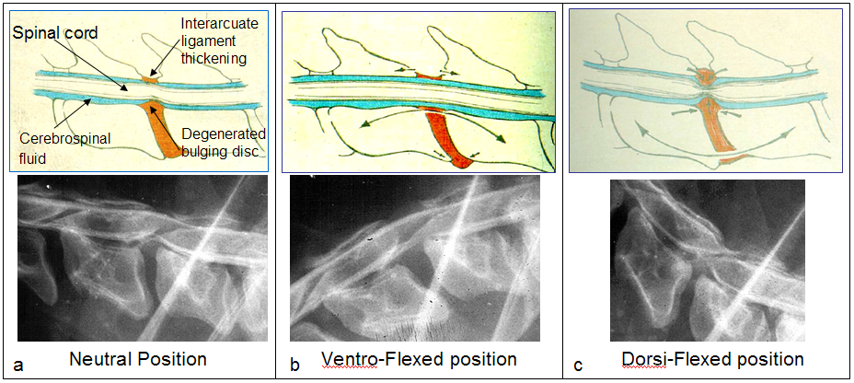
Figure 1. Schematic representation (upper row) and related radiographic abnormalities (lower row) showing the dynamic nature of DAWS. The upper row shows some of the anatomical structures involved in the of the spinal cord compression. The lower row is a myelography (under general anesthesia with dog lying on a lateral side) of a Doberman affected by DAWS. The degree of the spinal cord compression is alleviated by placing the neck in a ventro-flexed position and increased by placing the neck in an extended position. This also explains why dogs affected by DAWS, in the attempt to relieve the degree of spinal cord compression, are reluctant to raise their necks.

The collapsed disc space may also cause a narrowing of the intervertebral foramina (the small opening between two adjacent vertebrae where the nerves exit the spinal cord and the small arteries that nourish the spinal cord enter), which in turn may lead to nerve entrapment and spinal artery compression with subsequent radicular pain and decreased blood supply to the spinal cord.
Generally, these are traction-responsive lesions, in which the degree of spinal cord compression may be reduced by the application of traction to the cervical spine. This is usually seen using advanced imaging diagnostic technique (MRI or myelography) as explained later. The dynamic nature of the spinal cord compression is one of the key factors to confirm the diagnosis of DAWS. The cervical spinal traction re-establishes disc width, flattens the redundant soft tissue structures, and opens the narrowed foramina. In most dogs, 2-3 mm of distraction restores a normal disc width of 4-6 mm.

Diagnosis
Clinical signs
Animal affected with DAWS are usually 4-8 years of age. Clinical signs may range from only cervical pain (5-10% of patients) to paralysis. The most common presentation of DAWS is ataxia (lack of gait coordination), which is most severe in the pelvic limbs, in addition to cervical pain and low carriage of the head. A broad-based stance can be noticed in the hind limbs when the dog is standing. Affected dogs often show a characteristic gait, with the thoracic limbs moving with short stilted steps and the pelvic limbs moving with more wide steps. (Fig. 2) This is also known as a “disconnected” gait, where the thoracic limbs seem to advance at different rate. The owners commonly report a gradual onset, although the symptoms can sometimes occur or become exacerbated acutely. The disease is usually progressive if left untreated. The prognosis is usually worse for dogs with chronic clinical signs and paralysis.

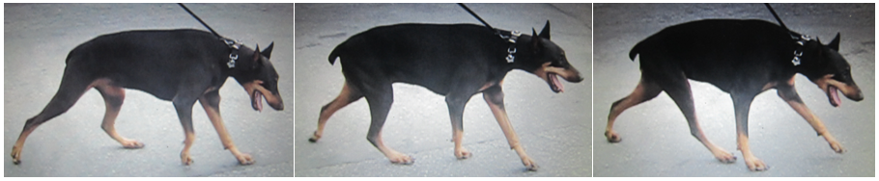
Figure 2. Sequence of pictures showing the typical posture and gait of a Doberman affected by Disc Associated Wobbler Syndrome: The neck is typically held either along an horizontal plane or ventro-flexed, the hind limbs are held wide apart and move with long steps, while the front limbs move with short steps with various degree of stumbling.

Survey radiographs
Survey radiographs may be suggestive of DAWS but they are not conclusive. They are used as a preliminary screening before pursuing more advanced imaging diagnostic techniques such as myelography, computed tomography (CT) and magnetic resonance imaging (MRI). Survey radiographs are useful to rule out other potential causes of cervical diseases such as vertebral fractures, subluxations, vertebral tumor, and bone or disc infectious diseases. Survey radiographs in dogs with DAWS may reveal narrowing of the intervertebral disc space, and mild deformity of the cervical vertebral body and spondylosis deformans ventral to the intervertebral space. However, changes on survey radiographs do not always correlate with spinal cord compression and they may be normal in some dogs with DAWS.

Advance Imaging Diagnostic (Myelography, CT and MRI)
Diagnosis of DAWS can be made by myelography or MRI with traction views. MRI is the best and least invasive way to diagnose DAWS. If MRI is not available, myelography (which includes an injection of contrast in the space around the spinal cord) would be an alternative way. Cross sectional computed tomography (CT) combined with myelography may also help to better visualize spinal cord compression and spinal cord atrophy. (Fig. 3)
In DAWS the extent of cord compression can vary with flexion, extension and linear traction (distraction) of the cervical spine. However, because of the risk of neurologic deterioration from cervical manipulation during general anesthesia, only linear traction myelography or linear traction MRI views continue to be routinely used.

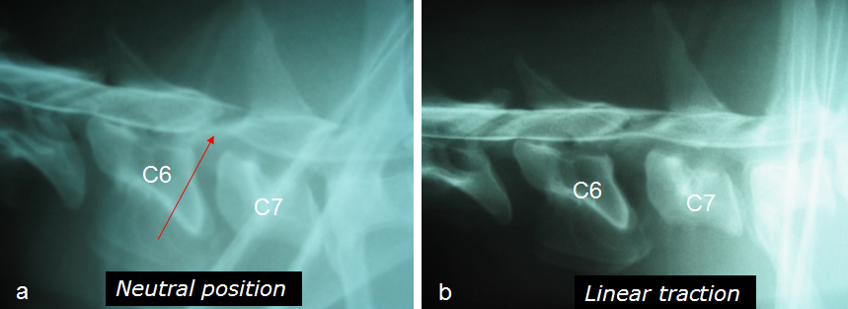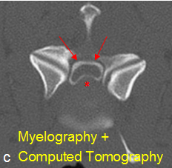

Figure 3. Lateral Myelography of a 5-year-old Doberman (a) and (b). Severe narrowing and wedging of the intervertebral disc space between C6-C7 is present; malformation of the cranioventral border of C7 is also evident. Severe ventral spinal cord compression is noted (a). The severity of the compressive lesion reduces remarkably in size with traction (b). Myelography and Computed Tomography (c). Transverse section of a spinal cord during Myelography and Computed Tomography at the affected site. The contrast injected in the space around the spinal cord (myelography: circular white line pointed by the red arrows), shows the distorted spinal cord shape (a normal spinal cord shape has a round circular shape) secondary to by ventral bulging disc and its associated ligamentous structures (asterisk).

MRI best defines the site, severity and nature of spinal cord compression, and allows visualization and characterization of lesions within the spinal cord. (Fig. 4) Association between spinal cord MRI findings and histologic abnormalities has been documented, and the type of the intra-spinal cord abnormalities seen on MRI may be of prognostic value.

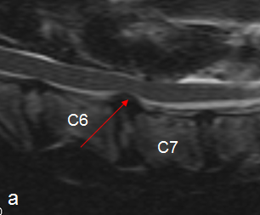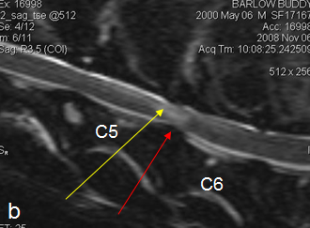

Figure 4. Sagittal MRIs of the cervical spine of a two dogs affected by DAWS. The dog in (a) presented with recurrence episodes of neck pain (red arrows shows the ventral spinal cord compression). The dog in (b) presented with a history of progressive uncoordinated gait for over one year; in this dog in addition to a moderate degree of ventral spinal compression (red arrow) are also visible additional abnormalities within the spinal cord (white patches area pointed by a yellow arrow) presumably reflecting intra-spinal scar-like lesions and indicating chronicity.

Static versus Dynamic lesion
The concept of static and dynamic lesions was first established in 1982. The determination of the “dynamic” or “traction responsive” feature, in contrast to “static” lesions (such as extruded disc material, malformed facets, or deformed vertebral arches), has been suggested as being essential for the diagnosis of DAWS. However, distinction between dynamic and static lesions is very subjective and difficult to determine. As a general rule the amount of traction applied to the dog’s head should be equivalent to 20% of the dog’s weight during MRI or myelography. This should generate enough traction to alleviate an in-traction responsive lesion causing spinal cord compression.

Treatment
Medical treatment
Medical treatment with activity restriction and corticosteroids may be indicated in a normal dog with a first episode of neurologic deficits following minor trauma; otherwise, surgery is the treatment of choice. Conservatively treated dogs should have activity restriction for at least two months. Recent studies that compared non-surgical versus surgical treatment, reported that 81% of the dogs surgically treated (via ventral slot, dorsal laminectomy or distraction fusion) improved, compared to other studies in which 54% and 45% of dogs, respectively, that improved with medical treatment. These studies concluded that conservative treatment for DAWS is associated with a guarded prognosis.

Surgical treatment
There are many surgical techniques described to treat DAWS, which can be broadly divided into two categories: direct access decompressive surgeries and distraction-stabilization surgeries. Direct access decompressive surgeries involve removal of the bulging degenerated disc and dorsal longitudinal ligament via a ventral slot or relieving the compression dorsally via a dorsal laminectomy.
- Dorsal laminectomy: this is the least used surgical technique, but it may be indicated for dogs with single dorsal lesions that do not respond to traction and to dogs with compression in multiple disc spaces. The major disadvantages are that extensive soft tissue dissection is required, the ventrally located disk material cannot be removed, and there is significant, short term morbidity with deterioration of neurological status, leading to considerable nursing problems. In one study, fourteen of twenty dogs undergoing dorsal laminectomy immediately declined in neurologic grade. Another major disadvantage is that the likely recurrence of the neurologic signs (reported in 10% of dogs) secondary to restrictive fibrosis during healing.

- Ventral slot: this technique has been used for a long time. This technique is associated with many problems and has been replaced by alternative techniques. Ventral decompression alone can be technically challenging and can exacerbate vertebral instability. (Fig. 5) Ventral decompression may result in further collapse of the disc space and worsen spinal cord compression because of additional in-folding of the ligament structures and joint capsules. Bleeding from the venous plexus (the venous structures within the spinal canal adjacent and surrounding the bulging disc) is also a major complication of ventral decompression. If bleeding occurs, it can prolong the duration of the surgery considerably, can lead to an incomplete spinal cord decompression and in rare cases requires a blood transfusion. In over 20% of patients treated with a ventral slot alone, failure to respond to treatment was associated with inadequate removal of disc material, which increased spinal cord compression as the intervertebral space collapsed at the treated site. Collapse of the intervertebral space can also compress the nerve roots in the intervertebral foramen, which can cause cervical pain and focal spinal cord ischemia. However, in the long term this technique has been reported to be clinically effective. This is most likely because the two vertebrae fuse (which may take 4-6 months), which resolves the vertebral instability, and promotes the re-absorption of the remaining thickened ligament structures.

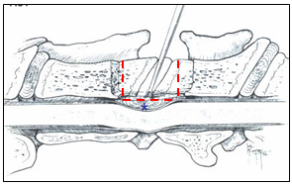

Figure 5. Schematic illustration of the Ventral slot technique. A slot is performed between the two vertebrae until the protruded disc with the associated thickened structures are reached and removed. After decompression nothing is placed in the created slot. Alternatively, to promote fusion, a cancellous bone graft harvest from the head of homerus is packed in the slot.

- Distraction-stabilization: This includes a number of new techniques which many surgeons apply as alternative to the ventral slot. Distraction-stabilization-fusion techniques distract the vertebrae to stretch the thickened ligament structures and relieve spinal cord compression. The vertebrae are then stabilized with appropriate implants and fusion is promoted with bone autografts (cancellous, cortical or corticocancellous) and cancellous bone allograft. Various techniques have been used to maintain distraction and/or graft retention to allow for bony fusion of the affected interspace. These include screws and washers, smooth pins, threaded pins or bone screws and polymethylmethacrylate (PMMA) bridges (Fig. 6), interbody or intervertebral cement plugs, modified K-wire spacers with bone screws and PMMA bridge, metallic plates (stainless still and titanium), plastic plates with unicortical and bicortical screws, and metallic plates with locking screws. Early implant failures with loss of distraction before fusion has been the most common cause of failure in distraction-stabilization techniques. Common complications include interspace collapse due to ventral or dorsal migration of the graft, penetration of bicortical pins or screws into the vertebral canal with spinal cord damage or vertebral artery or nerve root compromise. Other complications include fracture of bone cement bridges, pins, screws and plates, and various soft tissue complications, such as esophageal erosion because of ventral hardware or PMMA prominence. These disastrous complications have caused some surgeons to rely only on direct ventral decompression for both static and traction-responsive lesions. Many authors that use either direct or indirect decompression claim 70 - 90% success rate.

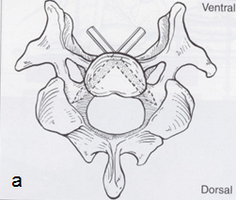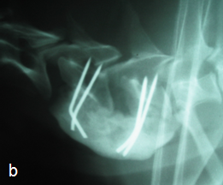
Figure 6. Distraction and stabilization by pins and bone cement bridge. After a standard ventral slot and spinal cord decompression, four pins (or screws) are placed at an angle, two in each vertebral body as shown in the schematic illustration (a), linear traction is then applied to the intervertebral space and it is maintained by a bone cement bridge, as shown in the immediate post-operative radiographs (b).

Domino lesion
Domino lesions or adjacent segment disease are believed to be the result, at least in part, of abnormal stresses imposed on one intervertebral space by fixation of an interspace adjacent to it. These stresses can exacerbate any pre-existing subclinical instability, and reproduce the same problem at an adjacent disc space. (Fig. 7) Recurrence of clinical signs secondary to a “domino” lesion may occur as a late post-operative complication with any of the above described techniques. Recurrence of paraparesis (lack of coordination in the hind legs) or tetraparesis (lack of coordination in all four legs) occurs in up to one third of dogs after either ventral decompression or metal implant and bone cement fixation. It usually occurs between six months and four years after the original surgery, with a mean recurrence of around two years. A recent study examining surgically treated DAWS dogs found an 80% short term success rate with about 20% of successful surgeries having significant recurrence after long term follow-up. The type of surgery performed (decompression versus distraction fusion), did not influence outcome. Given the high rate of surgical failure and long term recurrence, new methods are continually investigated for the treatment of DAWS in dogs.

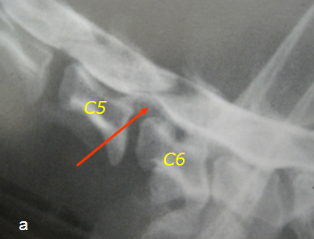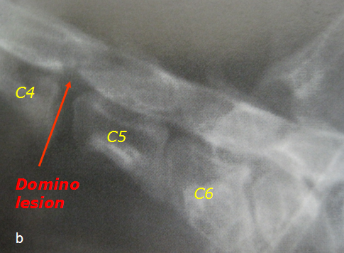
Figure 7. Domino lesion. Myelography of a dog diagnosed with DAWS at C5-C6 intervertebral space (a). This dog was surgically treated by standard ventral slot and presented again 18 months later with the same neurological signs. The second myelography (b) performed at that time showed a new “domino” lesion at C4-C5, which was not evident on the previous myelography, in addition to a complete intervertebral collapse at the treated C5-C6 space.

Cervical arthroplasty: Ventral spinal cord decompression and placement of artificial disc.
Cervical arthroplasty in people:
In people with cervical myelopathy and radiculopathy secondary to degenerative disc disease which are unresponsive to conservative medical care, spinal cord decompression by anterior cervical discectomy and fusion (ACDF) has been the standard of care for many years. Over ten years ago cervical arthroplasty was proposed as an alternative treatment to ACDF. In recent years, several designs of cervical arthroplasty have been developed and progressed to human clinical trial. Cervical arthroplasty in people is still an area of active research, debate and controversy. A technology overview from the American Academia of Orthopedic Surgeons (March 2010), which analyzed and compared the results of multiples clinical studies of patients treated with cervical arthroplasty and ACDF concluded that:
- Patients treated with cervical arthroplasty had a lower Neck Disability Index (NDI) score between 1 to 3 months after surgery compared to the patient treated with ACDF. Neck disability index score is the standard instrument for measuring self-rated disability due to neck pain; patients with lower NDI score are considered to have less disability when performing activities of daily living compared to patients with higher NDI scores.
- Patients treated with cervical arthroplasty had a statistically significantly success rate at 12 month follow-up; with significantly less pain between 1 to 6 months after surgery, than patients treated with anterior cervical discectomy and fusion.
- Patients treated with cervical arthroplasty at multiple levels had statistically significant less arm pain compared to patients treated with ACDF.
- Patients treated with cervical arthroplasty returned to work in statistically significant fewer days (range 14-16 days) compared to the patients treated with discectomy and vertebral fusion.
- However, in a long term (24 months following surgery), there were no significant statistical difference between the two techniques
Another recent study (Spine, April 19, 2011), showed that cervical disc arthroplasty increases total cervical range of motion compared with ACDF and maintains a physiologic distribution of the range of motion throughout the cervical spine at 2 years, potentially lowering the risk for adjacent segment breakdown.
However, in another study (Spine, March 25 2011), it was concluded that within 2 years the effectiveness of artificial cervical disc arthroplasty was similar to that of cervical fusion, and that there is weak evidence that cervical arthroplasty is superior to fusion for treating neck and arm pain.
In conclusion, in people artificial disc arthroplasty seems to be more beneficial in the short term compared to ACDF, but its benefit in the long term over the standard ACDF remains unclear and is an area of active research.

Cervical arthroplasty in dogs:
The goals of cervical arthroplasty are to preserve motion after neural decompression while providing distraction and stability. Ventral decompression via a mini-ventral slot and discectomy followed by the implantation of a cervical disc prosthesis in dogs with DAWS, has been recently investigated. (Fig. 8 and 9) This novel technique has the potential to achieve the optimal goal of spinal decompression, restoration of the biomechanics at the surgical treated sites, spares the adjacent disc spaces from the alterations in loading associated with the standard ventral slot and distraction-fusion surgical techniques, and potentially prevent the occurrence of a domino lesion.

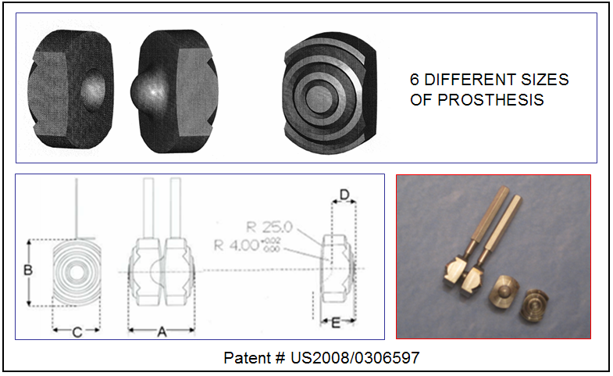
Figure 8. Canine cervical prosthesis. The prosthesis is made of titanium and consists of two separate shells. The external surface of each shell is convex to prevent migration. The concavity and the convexity in the center area of each surface acts like a ball and socket. Each surface has concentric grooves to allow bone in growth into the implant. The implant is held by a barrel holder and special screws and pins to facilitate handling during implantation.

Advantages of cervical arthroplasty over the standard surgical techniques:
The advantage over the standard ventral slot is that the artificial disc acts as an internal spacer preventing the early collapse of the vertebral space usually associated with ventral slot. The advantage over pins or screws and PMMA distraction fixation techniques is the elimination of the potential complications associated with pin impingement on neurovascular structures. The advantages over the distraction and fusion with plate and screws are that the artificial disc is a self-anchoring device which doesn’t require the expensive surgical equipment and cost associated with plating two vertebrae, and the elimination of the potential complications associated with these implant failures.

In a preliminary in vitro study in dogs (Adamo et al. Veterinary Surgery 2007) it was concluded that cervical spine specimens with the implanted prosthesis have biomechanical behaviors more similar to an intact spine compared to spinal specimens treated with ventral slot and PMMA distraction fusion techniques. In a recent clinical pilot study (Adamo et al., Annual ACVIM Forum, Montreal, Canada, 2009) for the first time an artificial disc in Titanium was implanted in two dogs clinically affected by DAWS. Since then additional cases were successfully treated with cervical arthroplasty (Adamo, Annual ACVIM Forum, Colorado, CA, 2011, and Adamo, JAVMA 2011 in press). The artificial disc used is specifically designed and manufactured for the dog’s cervical spine, it is relatively easy to implant, it is cost-effective (its cost may be significantly less compared to the fusion techniques) and it could be applied to multiple sites if needed. This technique is minimally invasive; it reduces the surgery time and the post-operative recovery time, including nursing care and hospitalization time. Dogs that are ambulatory can go home the day after surgery. This could potentially be an outpatient surgery.
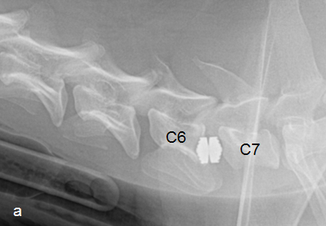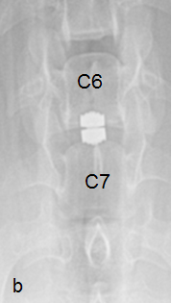
Figure 9. Cervical prosthesis implanted in a 4 year-old Doberman affected by DAWS at C6-C7 space. Immediate post-operative radiographs in lateral view (a) and ventro-dorsal view (b) show a well-seated implant and adequate distraction of the intervertebral space treated. This dog had a normal MRI at 2 year follow-up, and he is still asymptomatic 2 and ½ years after surgery.

In all treated dogs a good distraction at the treated site was achieved at the time of surgery, the implant was well tolerated and there were no signs of implant infection on the serial post-operative radiographs. All dogs treated had an excellent short and long term clinical outcome; two dogs were followed up to over two and half years and at the re-check MRI two years after surgery showed no signs of compression at the treated sites and the remaining cervical discs had no signs of degeneration. (Fig. 10) The possibility of performing MRI studies after implantation of this prosthesis, without interfering with spinal cord visibility, is an advantage over any other distraction stabilization techniques reported at this time. This allows, in the event of a recurrence of clinical signs, an accurate re-evaluation of the spinal cord at the treated site as well as in adjacent locations, for an early detection of domino lesion or other spinal cord diseases.
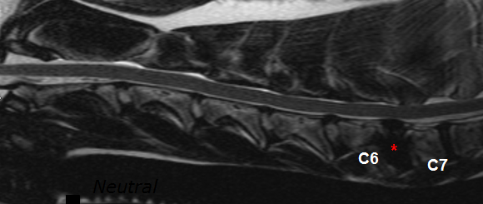
Figure 10. MRI of the same dog in Fig. 9 at two year follow-up. The artificial disc is well in place (asterisk) with no signs of spinal cord compression at the treated and at the adjacent disc spaces.
Maintenance of distraction after direct spinal compression immediately and effectively relieves the mechanical compression caused by the redundant dorsal annulus and/or ligamentum flavum. The cervical prosthesis provides immediate distraction at the treated site which further decreases any residual compression from the redundant ligament structures, and relieves spinal cord ischemia caused by compression of the vertebral spinal artery. The reopening of the narrowed intervertebral foramina further decompresses the nerve roots, eliminating recurrent cervical pain.
Of particular interest, one of the dogs treated with cervical arthroplasty, had a double lesion, one chronic (at C5-C6) and previously medically treated for two years with non-steroidal anti-inflammatory medication, and a new one (at C6-C7) that caused the dog to become acutely paralyzed. (Fig. 11) This dog was successfully treated with a multi-level cervical arthroplasty implanting one artificial disc at each affected site. Two days after surgery, the dog became ambulatory, and shortly after he left the hospital pain free. This dog is currently (four months after surgery) free of neurologic signs and pain free, without analgesics or anti-inflammatory medications. According to the owner he regained his normal neck posture which he had lost about two years prior the surgery.

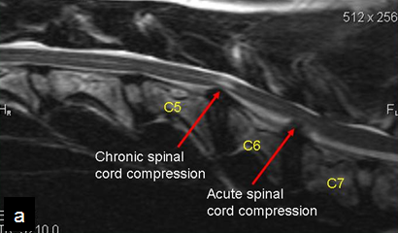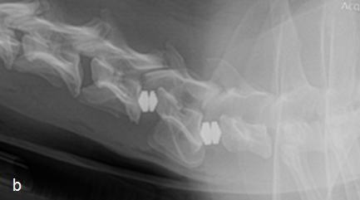

Figure 11. MRI and cervical prosthesis of a 6 year old Doberman affected by DAWS at two sites. The lesion at C6-C7 is more recent, while the lesion at C5-C6 (because of the intra-spinal cord changes: white patch) is more chronic. This dog was successfully treated with two cervical prosthesis implantation, one at each affected site.

Conclusions
Disc associated Wobbler syndrome is a relatively common cause of chronic spinal cord compression in adult large breed dogs. This disease can be very challenging, both for the referring veterinarian and even for the specialist. It may be devastating for the affected dog and very stressful for the owner who must to make decisions regarding the care of their pet. Disc associated Wobbler syndrome is considered a surgical disease, although the ideal surgical procedure still doesn’t exist, preliminary clinical studies are showing that cervical disc prosthesis is a valuable method to treat DAWS in dogs.

Acknowledgments:
The author wish to thanks:
1. The University of Wisconsin – Madison School Veterinary Medicine which founded the study for designing, developing and testing the canine cervical disc described in this article.
2, Robert and Cris Tarrozi, and the White Kitty Foundation, for their generous contribution in supporting the ongoing clinical study, investigating the benefit of cervical arthroplasty in dogs.
3. Dr. Peter Nurre for his critical revision of this article, and Ashley Core for her revision of the English language.

Canine artificial disc project for DAWS – Donations
Further studies with a larger number of patients, with a longer follow-up is necessary to investigate and document the effectiveness and the complications of cervical arthroplasty in dogs affected by DAWS. Because of the large scale shortage in research funding, private donations at this time are the main way to make progress in this field. We are looking forward to forging significant progress in the treatment of this devastating disease in dogs and even small donations can make a significant difference. Contribution can be made by either contacting Dr. Adamo directly at flppadamo@yahoo.com or by sending a check to the order of Bay Area VNC, 208 Santa Clara Way, San Mateo – CA 94403, specifying that the donation is for the canine artificial disc project. Thank you in advance for your generous contribution.

